Peek Magazine inc. subscription handling system
System level DFD By – Ashveen

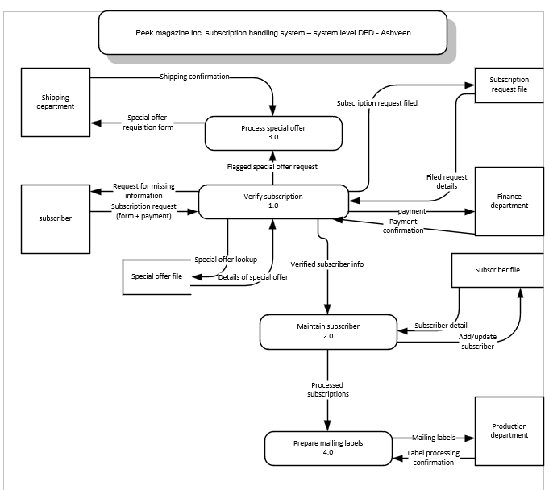

Assumptions:
- All subscription requests are received by the system with a form and payment information together.
- The system checks that all required details are included
- If something is missing or incorrect the system sends a message to the subscriber asking for missing information
- The finance department then handles the payment, and the system receives confirmation that the payment was accepted.
- The system only updates the subscribers record after the payment is confirmed
- The special offer file contains all current special offer and then system can look up after details whenever needed.
- If any subscription includes a special offer, it is marked for special offer processing.
- The shipping department is responsible for sending special offer items and sends confirmation back to system.
- The subscribers file stores information of both new and existing subscribers
- If a subscribers already exists the system then updates their information instead of creating a new record.
- The subscriptions request files stores all subscriptions requests and their status as complete , incomplete , processed etc.
- Mailing labels are prepared at the end of each day for all subscriptions processed on each day
- The production department receives mailing labels and confirms when they are processed
- The system only handles subscription processing and does not include physical mailing or financial accounting activities.
Modelling:
The Peak magazine subscription handling system is a system that will receive subscription requests, checks the request and payments then updates the subscribers records and handles special offers then it prepares mailing labels for delivery.
External entities in this system are Subscriber, Financial department, Shipping Department and Production department. And then we have data stores that is subscription request file, subscriber file and special offer file.
- Subscriber send subscription request to the company
- The system receives the request and check if the form has all required details.
- If the request looks complete the system forwards the payment info to finance department.
- The finance department processes the payment and sends back the confirmation
- The system stores the verified request in the subscription request file.
- The system checks the subscribers file to see if the person already a subscriber
- If the person already a subscriber then system updates the record otherwise a new subscriber record is created.
- After updating or adding the system marks the subscription as processed
- If the request include special offer then the system flags it for special offer handling
- The system looks for special offer file to confirm what the offer includes
- The system creates special offer requisition form and sends it to shipping department
- The shipping department ships the offer item and sends back the confirmation
- The system records that the special offer was handled.
- At the end of day, system gathers all subscription that were processed
- The system uses address from the subscriber file to create mailing labels.
- The system sends mailing labels to production department
- The production department confirms labels were processed and sends back a label confirmation to the system.

